EXPERIMENT 3

AIM:
MATLAB-Based Modeling of VSB Modulator and Demodulator for Analog Television Communication Applications.

SOFTWARE REQUIRED:
MATLAB Simulink

PROGRAM:
Clc; clear; close all;
Fs=10000;
T=0:1/fs:0.1;
Fm=100; fc=2000;
M=cos(2*pi*fm*t);
C=cos(2*pi*fc*t);
Dsb=m.*c;
Vsb=dsb.*(1+0.2*cos(2*pi*fm*t));
Demod=vsb.*c;
Plot(t,m,’b’,t,vsb,’r’,t,demod,’g’);
Legend(‘Message’,’VSB’,’Demodulated’);
Xlabel(‘Time’); grid on;
Title(‘VSB Modulation and Demodulation’);

OUTPUT:
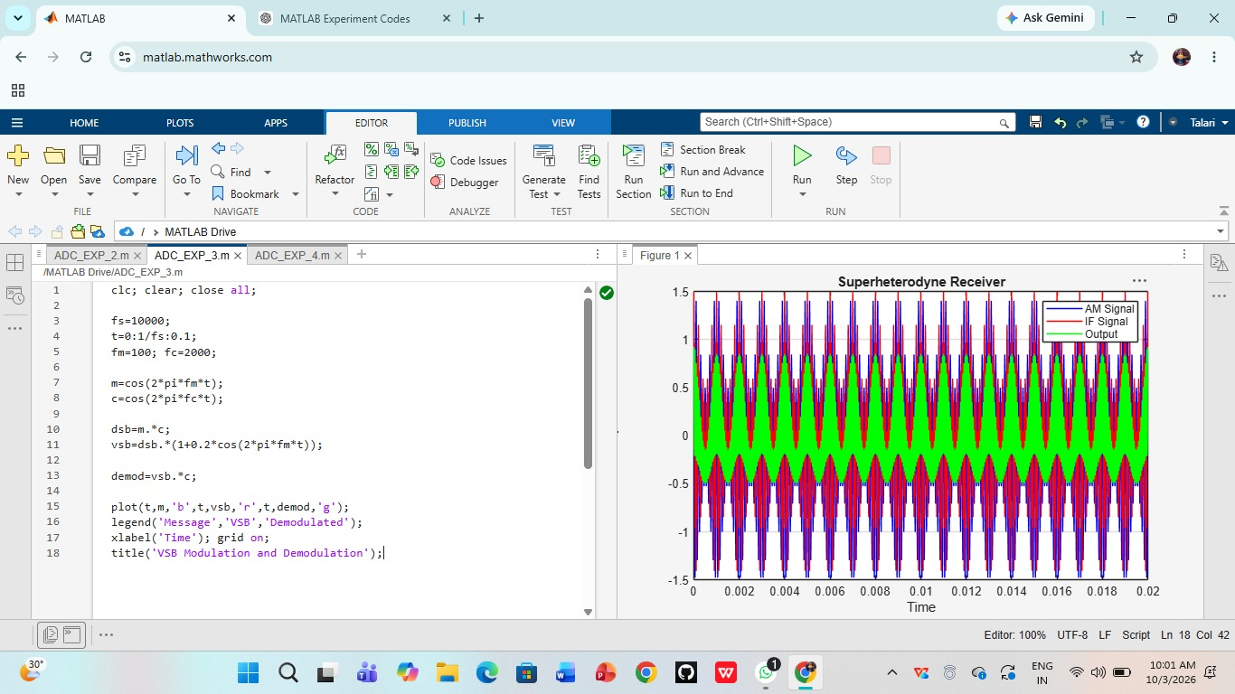

RESULT:
Thus, VSB modulation and demodulation for analog television communication was successfully demonstrated using MATLAB.

